
AICT LAB PROJECT REPORT
Title: Personal Expense Tracker System
Submitted to: Mr. Noman Muneer

Project Members
- Muhammad Umar: 2025-CS-653
- Muhammad Sharjeel:2025-CS-651
- Abdullah Abid:2025-CS-613
- Muhammad Arslan:2025-CS-642

Personal Expense Tracker System

- Introduction:

- Managing daily expenses is an important part of personal financial planning.
- The Personal Expense Tracker (PET) System is designed to help users record and monitor their spending efficiently.
- This project provides an organized way to store expense details such as amount, category, and date.
- It applies structured programming concepts to develop a simple, user-friendly application.
- A web-based user interface developed using HTML and CSS.

- Objectives:

- To design and develop a simple Personal Expense Tracker system.
- To enable users to record, update, and delete daily expense entries.
- To categorize expenses for better organization and analysis.
- To generate weekly or monthly expense summaries.
- To apply structured programming logic in a practical application.
- To apply structured programming logic in a practical application.

- Project Overview:
- It helps user record expense details such as amount, date, category, and description.
- The system provides options to add, update, and delete expense records.
- Expenses are organized into categories to make tracking and analysis easier.
- The application generates summaries to help users understand their spending patterns.
- The project is developed using structured programming techniques with a focus on simplicity and usability.

- Technology Stack:

Frontend: HTML5, CSS3, Vanilla JavaScript

Charts: Chart.js Library

Icons: Font Awesome 6.4.0

Storage: Browser Local Storage API

Responsive Design: CSS Flex box and Grid.

- Features:

Dashboard: Real-time overview of financial status

Add Expenses: Simple form-based expense entry

Visual Reports: Interactive charts and graphs

Expense Management: Full CRUD operations (Create, Read, Update, Delete)

Search Functionality: Quick expense lookup

Data Persistence: Automatic save and load functionality

- Advanced Features:

Category-wise Analysis: Pie charts showing spending distribution
Monthly Trends: Bar charts displaying expense patterns
Custom Reports: Filterable by period and category
Responsive Design: Works on mobile, tablet, and desktop
Sample Data: Pre-loaded examples for demonstration

- Implementation Details:

- HTML Structure:
The application follows a sidebar layout with:
- Fixed navigation sidebar.
- Main content area.
- Multiple page sections (Dashboard, Add Expense, Reports, All Expenses)
- Modal for editing expenses.

- CSS Design Principles:
Colour Scheme: Professional blue/green palette.
Layout: Flex box and CSS Grid for responsive design
Typography: Clean, readable fonts
Spacing: Consistent padding and margins
Transitions: Smooth hover and click effects

- JavaScript Implementation:
- Key Functions:

Add Expense () - Validates and saves new expenses

Save To Local () - Stores data in browser storage

Load Dashboard () - Calculates and displays statistics

Create Category Chart () - Generates pie chart visualization

Generate Report () - Creates filtered financial reports

- Event Handling:

- Form submissions for adding/editing expenses.

- Navigation clicks for page switching.

- Input events for real-time search.

- External Libraries:

- Chart.js:

Purpose: Data visualization

Version: Latest (via CDN)

Charts Used:

Pie Chart: Category distribution
Bar Chart: Monthly trends
Line Chart: Time-based reports

- Font Awesome:

Purpose: Icon library

- User Interface Walkthrough:

- Dashboard Page:
Primary Function: Overview and quick insights.

Statics Card:

- Total Expenses (all-time)
- This Month's Spending
- Top Spending Category
- Daily Average

Charts Section:
- Category Distribution (Pie Chart)
- Monthly Trend (Bar Chart)

Recent Expenses Table:
- Last 5 expenses
- Date, category, description, amount
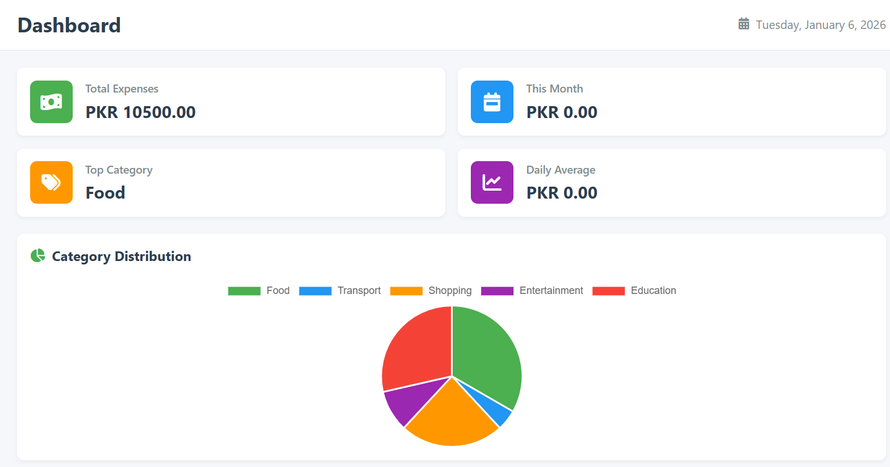
Dashboard Showing Statics Charts and recent expenses

- Add Expense Page:

Primary Function: Data entry
Form Fields:
Amount: Numeric input (PKR)
Category: Dropdown selection (8 categories)
Date: Date picker (defaults to current date)
Description: Optional text area
Buttons: Save and Clear

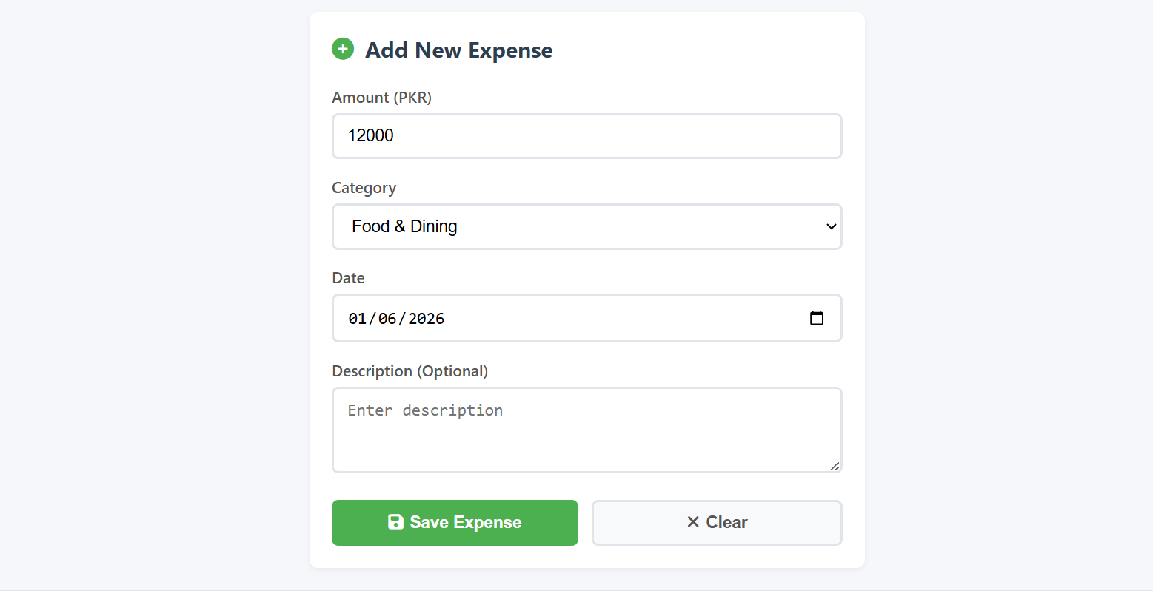
Form for entering new expenses with category selection

- Reports Page:

Primary Function: Analytical insights
Filters:

- Period (Weekly/Monthly)
- Category (All/Specific)
Summary Cards:
    - Total in Period
    - Average Daily
    - Highest Expense
    - Entries Count

Visual Report:
- Line chart showing trends
Report Data Table:
- Filtered expenses list

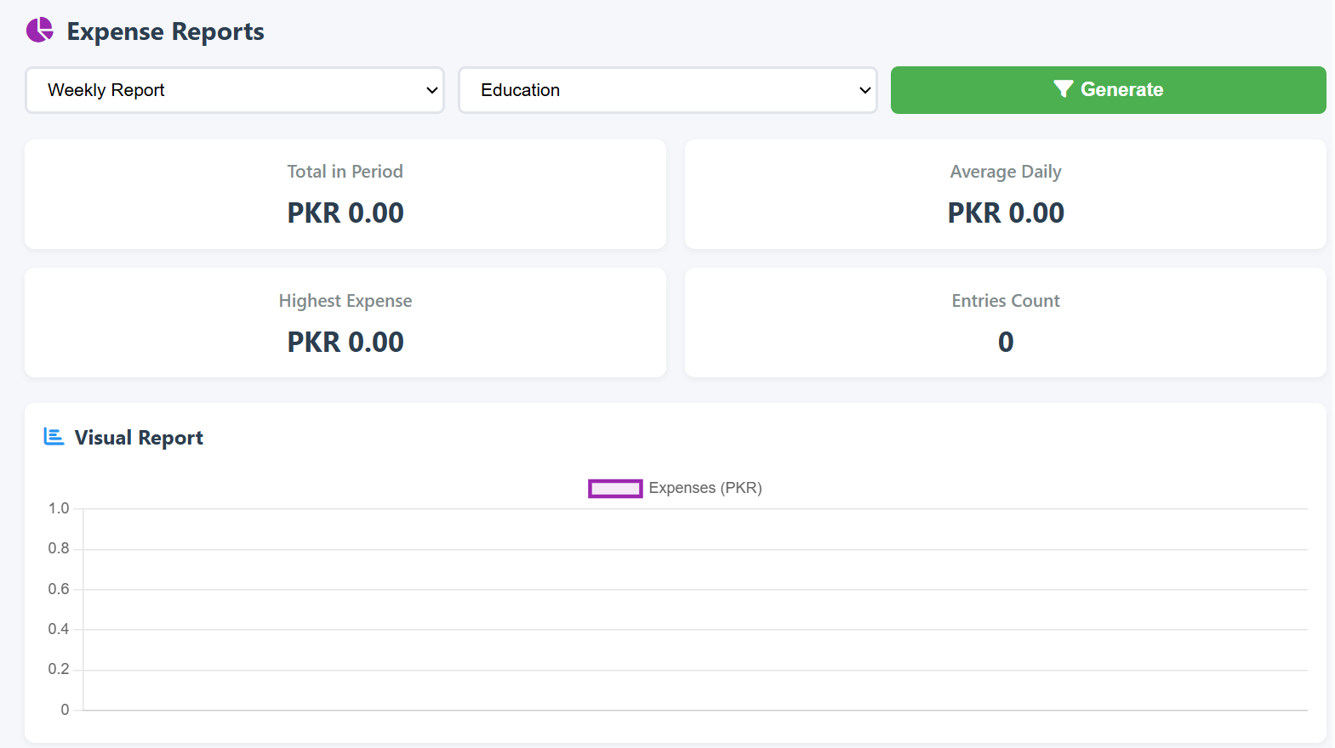
Filterable reports with visual charts and data tables
- All Expenses Page:

Primary Function: Complete expense management

Features:

Search Box: Real-time filtering

Expense Table: All recorded expenses

Action Buttons: Edit and Delete for each entry

Delete All: Mass deletion (with confirmation)

Record Count: Total expenses counter

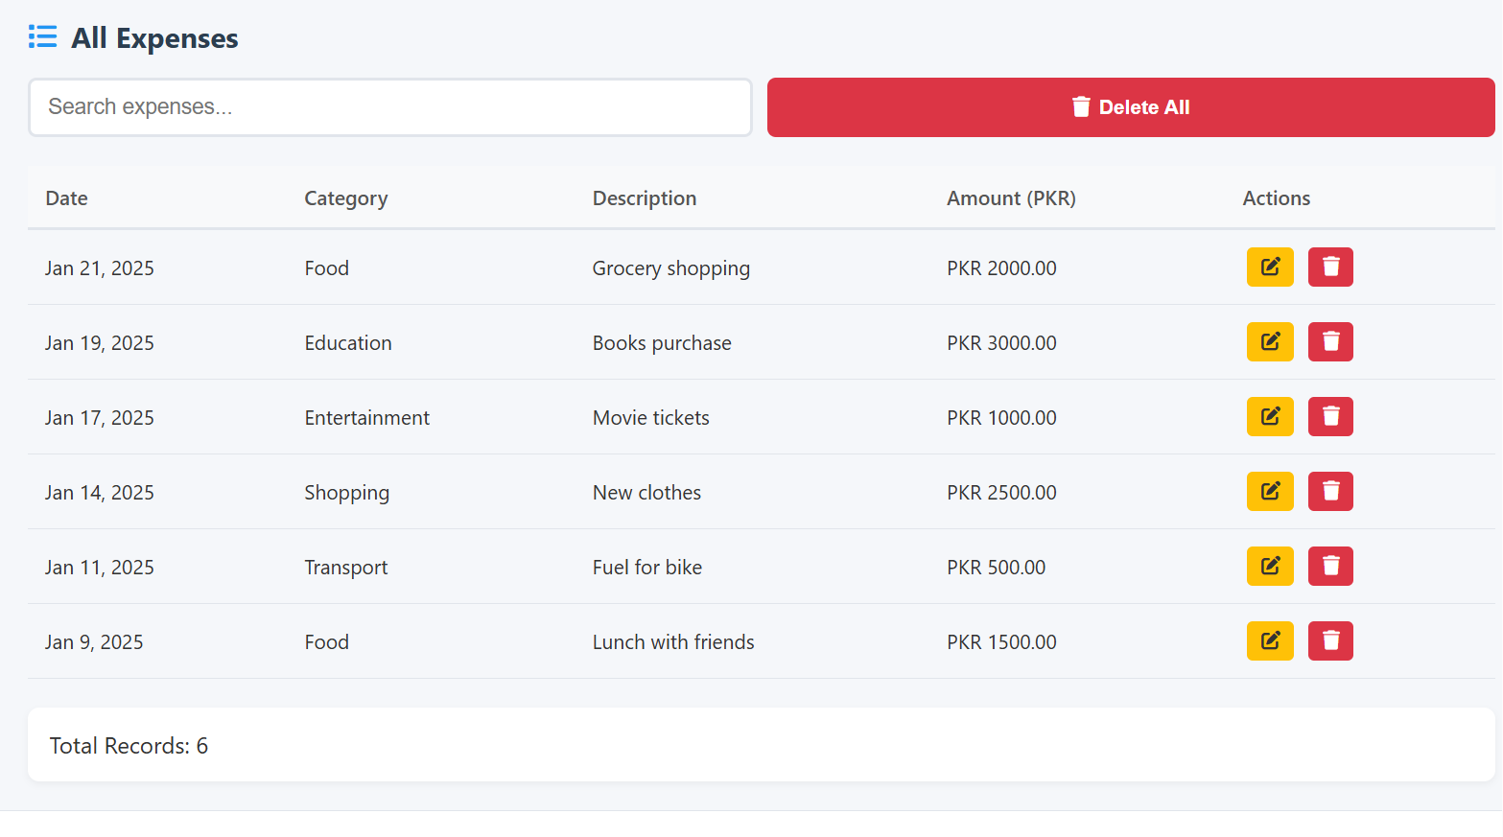
Complete expense list with search and edit/delete options

.

